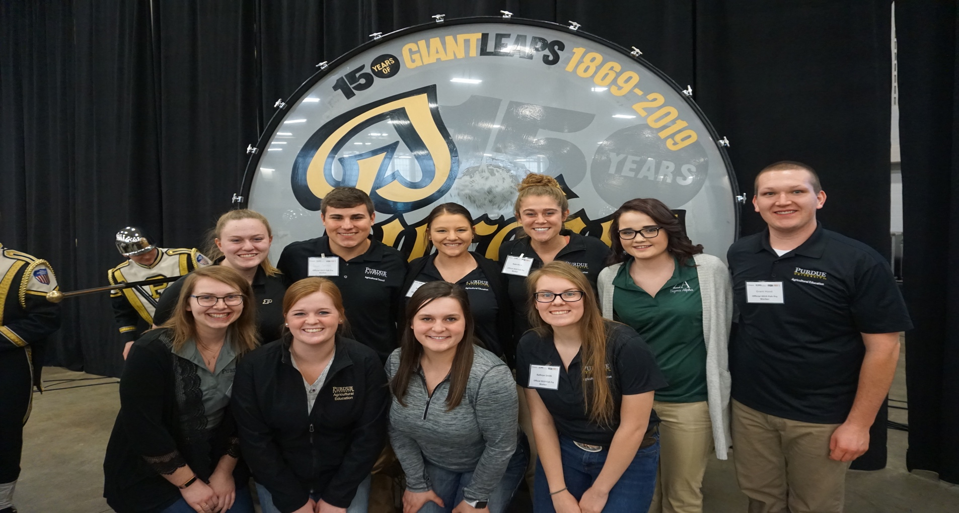

IAAE Newsletter

Events to Look Forward to After Spring Break!

Events to Look Forward to After Spring Break!

“It's the possibility of having a dream come true that makes life interesting." -Paulo Coelho

Inside This Issue

Fish Fry

Hot Chocolate Social

240 Speaker

New Officer Introductions

Member Spotlight

Fun Page



Kylei Klein, Sophomore



Spring Fling: March 24

Purdue Ag Week: April 8-12

IAAE-Purdue Banquet: April 13

Collegiate Exchange: April 6 &7

Mariah Merryman, Junior

Fish Fry

Written by Kayla Carson

On February 2nd, hundreds of Purdue Ag Alumni, supporters, staff, and students gathered at the Indiana State Fairgrounds for the annual Purdue Agriculture Fish Fry. To help celebrate 150 Years of Giant Leaps, five past College of Agriculture Deans gathered for a discussion panel that was led by agriculture broadcast journalist, Max Armstrong. On the discussion panel were Karen Plaut, the Glenn W. Sample Dean of Agriculture and former deans Bob Thompson, Vic Lechtenberg, Randy Woodson, and Jay Akridge. The panel discussed how the College of Agriculture is taking “Giant Leaps” in improving the education of future agriculture students. While the discussion proceeded, members enjoyed the fish dinner and finished off with Purdue’s ice cream, Boiler Tracks!

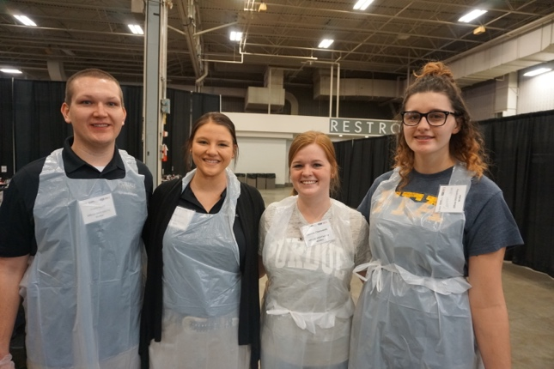



Hot Chocolate Social

Written by Kyle Swafford

Not much is better than a cup of hot chocolate on a cold day. Adding toppings and the experience of meeting other agriculture majors makes that hot chocolate 10 times better. The Purdue Agriculture Council on Wednesday, January 16th hosted the annual Hot Chocolate Social in the lobby of Krach Leadership Center. This event is the perfect place for students in the College of Ag to find different organizations they can join. Each organization in attendance provided a topping that students could put in their cup of hot chocolate. IAAE-Purdue was one of the organizations in attendance that also had a display and offered whipped cream to top student’s hot chocolate. This event is one of the best places to have a cup of hot chocolate and meet other students in the College of Ag outside your major. This was definitely a successful event and one that IAAE-Purdue will be looking forward to participating in next year.

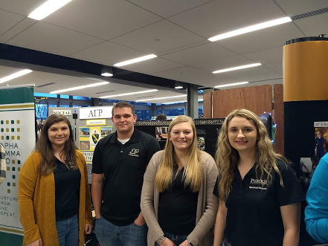



**240 Speaker: Leslie Fairchild**

**Written by Brittany Young**

On February 19, 2019, Mrs. Leslie Fairchild, agricultural educator with the Indiana Agriculture and Technology School came and spoke to our YDAE 240 class. Explaining this first ever virtual ag school in the nation to our class was a fascinating experience to learn more about. Mrs. Fairchild shared that there have been many challenges and a lot of strides are still needing to be made but the future of this virtual school is bright!

Mrs. Fairchild uses Google classroom, using a blended school model, while all classes are online, virtually. The outline of this structure equals out to 51% is face to face and 49% is completed on the computer. Mrs. Fairchild teaches live once a week and travels around the state to meet the needs of her students. A large majority of her students are homeschooled and this online virtual school has allowed these students to experience agriculture classes in a unique way. In many cases, they may have never experienced an agriculture education classroom.

The school does have a 600-acre farm, comprised of 200 acres of forest, 200 acres’ row crop, 200 acres’ pasture, 50 head of cattle, and 9 bodies of water. All students are required 250 hours of field experience, equivalent to an SAE, or Supervised Agricultural Experience. This beginning FFA chapter is already diving into their leadership opportunities. They took a group of students to LDW just a few months ago with their current leadership officer team. The students and administration are excited for the future of their program and the future of virtual schools across the nation, enabling students to experience agriculture in a unique way!

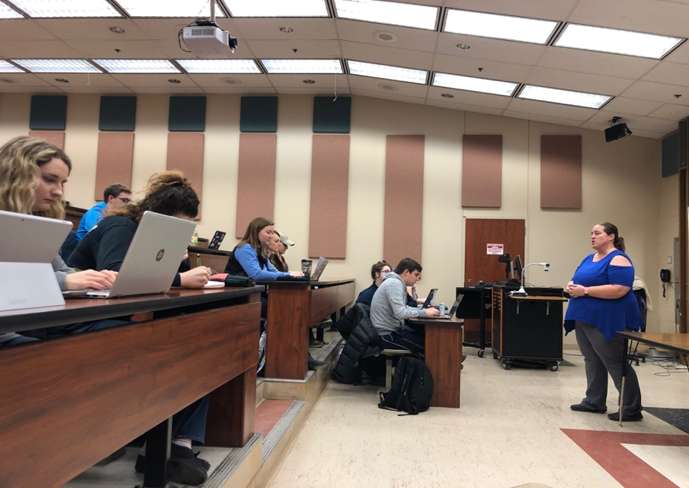



**2019 IAAE-Purdue Officers**

**Written by Carly Grieshop**

Leah Jacobs

President

**What is your favorite TV show?** Cupcake Wars

**What is your favorite place to eat on campus?** Pappy’s

**If you could be any Disney character, who would you be?** Elsa from Frozen

**If you were to bury a time capsule that you would open in 50 years, what would you put in it?** Pictures, my journal, nametags, and memorabilia from college events.

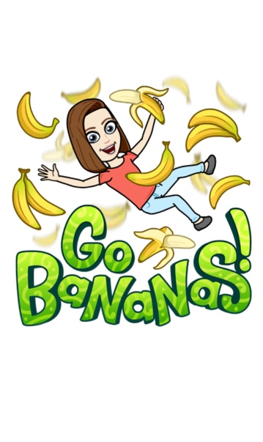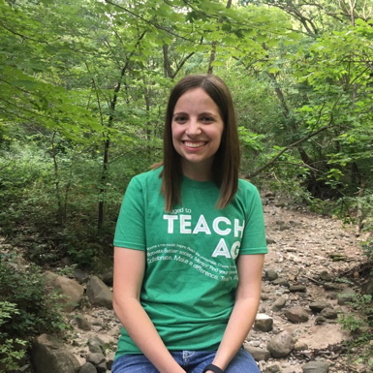

Logan Glassburn

Vice President

**What is your favorite TV show?** Grey’s Anatomy

**What is your favorite place to eat on campus?** Starbucks

**If you could be any Disney character, who would you be?** Buzz Lightyear from Toy Story.

**If you were to bury a time capsule that you would open in 50 years, what would you put in it?** I would put my iPhone in a time capsule to see if it would even be compatible with technology when we open it.

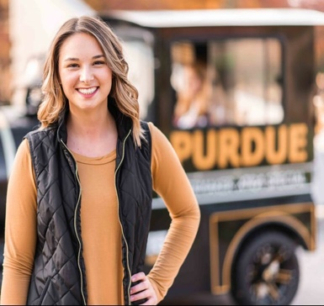

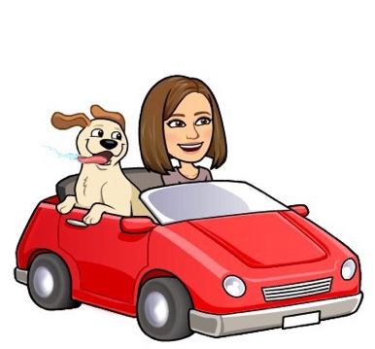

Damion Watters

Secretary

**What is your favorite TV show?** American Pickers

**What is your favorite place to eat on campus**? Hotbox Pizza and Pappy's milkshakes

**If you could be any Disney character, who would you be?** Winnie the Pooh

**If you were to bury a time capsule that you would open in 50 years, what would you put in it?** Twinkies, CDs, and a Purdue Big Ten t-shirt.

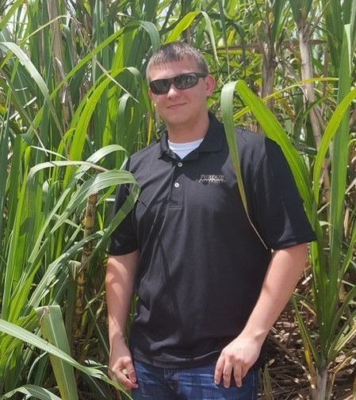



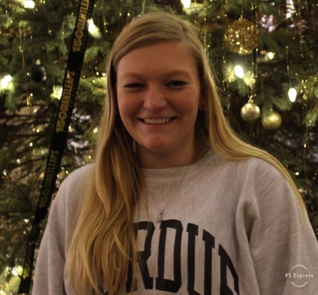

Lindsay Yeager

Treasurer

**What is your favorite TV show?** How I Met Your Mother

**What is your favorite place to eat on campus?** Chick-Fil-A

**If you could be any Disney character, who would you be?** Crush from Nemo.

**If you were to bury a time capsule that you would open in 50 years, what would you put in it?** I'd put my possessions that mean the most to me like family pictures and stuff.

Kayla Carson

Reporter

**What is your favorite TV show?** Grey’s Anatomy

**What is your favorite place to eat on campus?** Discount Den for a doughnut and a Den Pop.

**If you could be any Disney character, who would you be?** Arial from The Little Mermaid.

**If you were to bury a time capsule that you would open in 50 years, what would you put in it?** Pictures, CD’s with music that is currently popular, and a letter from my 22-year-old self to my 72-year-old self.

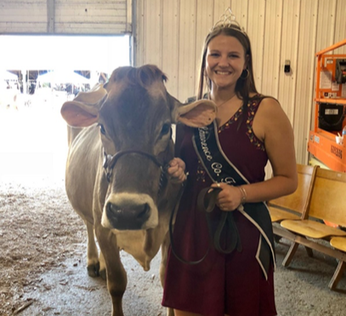

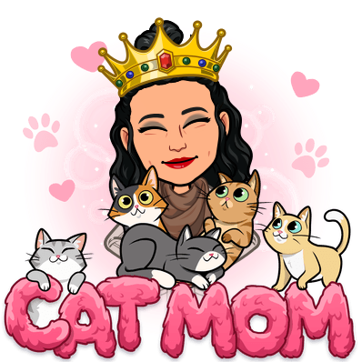

Jacquelyn Berkey

Vice President of Public Relations

**What is your favorite TV show?** Grey’s Anatomy

**What is your favorite place to eat on campus?** Panera Bread

**If you could be any Disney character, who would you be?** Tinker Bell from Peter Pan

**If you were to bury a time capsule that you would open in 50 years, what would you put in it?** If I were to bury a time capsule, I would put something that reminds me of all of my favorite horses I've worked with (like horseshoes, various pieces of tack, etc.) in it.

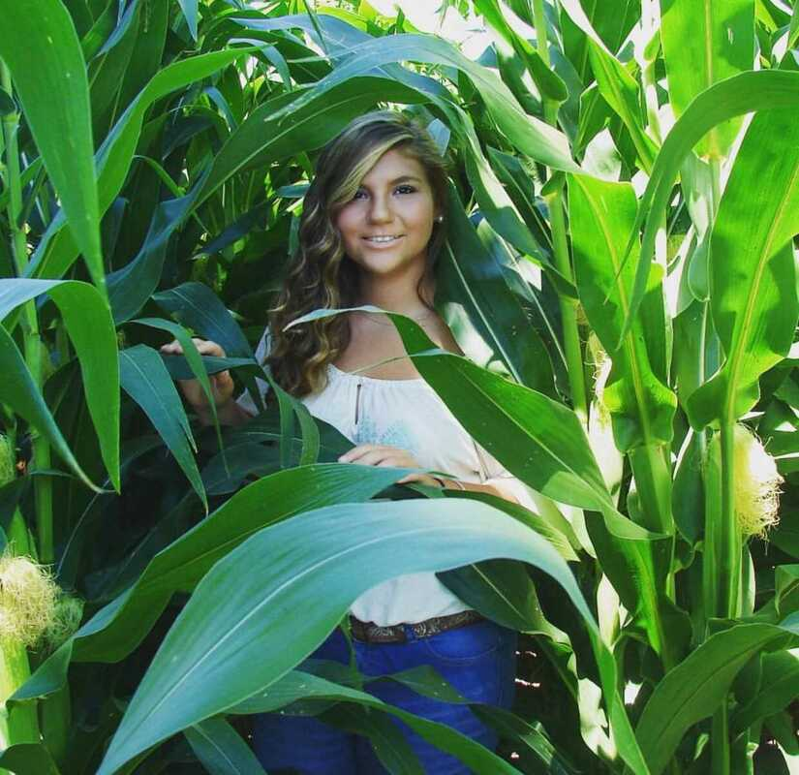



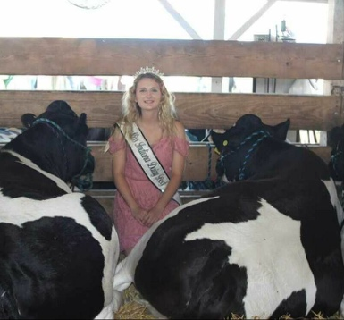

Melissa Ann Rudolph

Vice President of Campus Relations

**What is your favorite TV show?** Grey’s Anatomy

**What is your favorite place to eat on campus?** Pappy’s

**If you could be any Disney character, who would you be?** Princess Merida from Brave

**If you were to bury a time capsule that you would open in 50 years, what would you put in it**? If I were to bury a time capsule I would put a couple of my high school books that I no longer need in. So people in the future can compare their curriculum to the one we have now.

Emily Kilmer

Vice President of Finance and Marketing

**What is your favorite TV show?** Greys Anatomy

**What is your favorite place to eat on campus?** Triple X

**If you could be any Disney character, who would you be?** Merida from Brave

**If you were to bury a time capsule that you would open in 50 years, what would you put in it?** I would put photos of my family and friends, my Bible, and some money in it.

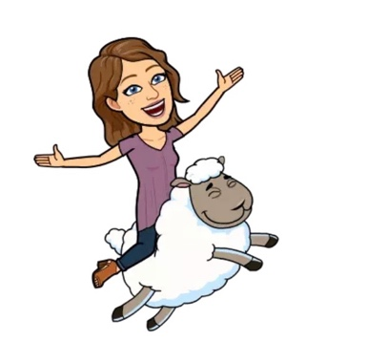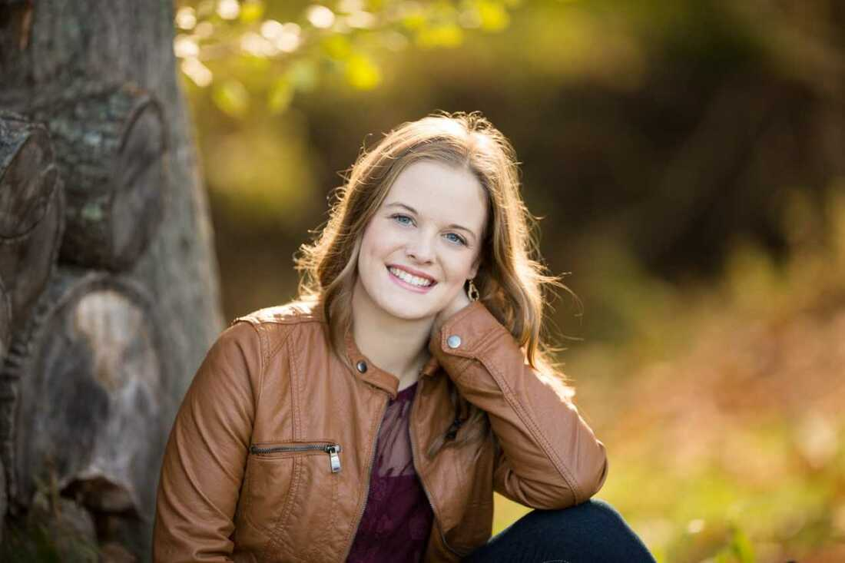

**Our Awesome Faculty & Staff!**





Melissa Geiger

Dr. Talbert

Amy Conrad

Dr. LaRose

Hannah Lyon, Senior

**Member Spotlight**

**Written by Brittany Young**

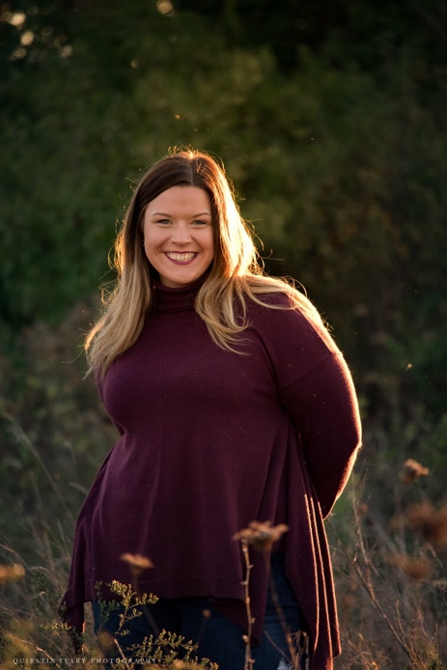

**Favorite color:** Turquoise

**Favorite place to eat:** Texas Roadhouse

**Favorite animal:** My Beagle, Ruby Grace

**Favorite song: “**She’s Got This Thing About Her” by Chris Young

**Favorite season:** Fall

**Previous FFA activities:** Floral demonstrations and horticulture

**Favorite memory of Purdue?** Learning how to skateboard with Jessica Jones outside of McCutcheon Hall at 1am on a Friday morning before going to breakfast with my parents after a week of fasting. Oh! Not to mention the 8:30 class we had that morning as well!!!

**Why Agricultural Education?** I LOVED being in education and helping others learn but when my freshman year Ag class went to AgDay at the county fairgrounds, I got stuck in a pen with a bull all day and fell in love with livestock which sparked a continuation in learning about agriculture. When I could no longer pursue music education due to carpal tunnel I continued to pursue agriculture.

**Why Purdue?** I originally started in the Pathways program as a way to save money while attending college. However, I had to move home my spring semester of freshmen year and took a year completely at Ivy Tech. Coming back to Purdue was refreshing and exciting as I lived on campus, stayed active in clubs, church and friend groups and will soon graduate from Purdue after receiving my Associates Degree in Science from Ivy Tech.

**Favorite class at Purdue?** Entomology

**Greatest piece of advice?** DO NOT PROCRASTINATE.

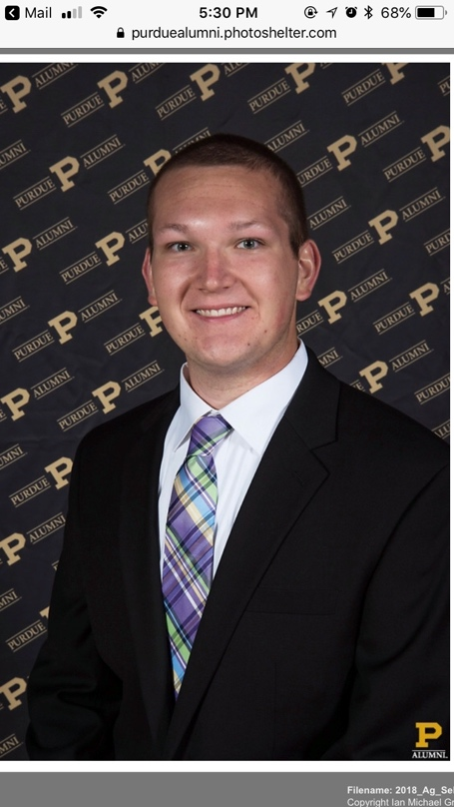

**Favorite Color:** John Deere Green

**Favorite place to eat:** Arni’s

**Favorite animal:** Goat

**Favorite song:** “John Deere Green” by Joe Diffie

**Favorite season:** Fall Harvest

**Previous FFA activities:** CDE’s, State Convention, National Convention.

**Why Agricultural Education?** I chose agricultural education to share knowledge and experiences with future generations of students as well as provide the opportunity of agriculture education and FFA/SAE to students.

**Why Purdue?** I chose Purdue because it is my goal to become an Ag educator and this was the only program in the state. I did not have the minimum high school requirements or an SAT score when I decided to come to Purdue, so I chose to start my journey at Ivy Tech Northeast (Fort Wayne). This was beneficial to me in two ways, I lived at home and worked while getting my associates of science in agriculture.

**Favorite class at Purdue?** YDAE 318

**Greatest piece of advice:** Never say no to opportunity.

Grant Hood, Junior

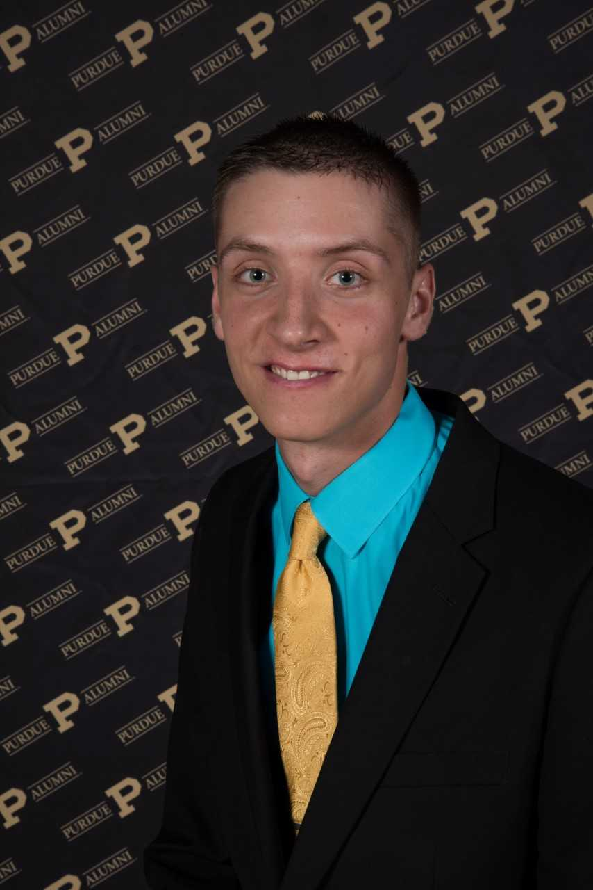

**Favorite color:** Green

**Favorite place to eat:** Pappy's Sweet Shop

**Favorite animal**: Beef Cattle

**Favorite song:** "Little Bitty" Alan Jackson

**Favorite season:** Fall

**Previous FFA activities:** Parliamentary Procedure, Soils judging, Livestock Judging, & Extemporaneous Public Speaking.

**Favorite memory of Purdue so far?** When Purdue upset #2 Ohio State in football.

**Why Agricultural Education?** I grew up around Agriculture all my life! Why not use that knowledge and experience to teach and educate students who do not have the opportunity to do the things that I did in high school.

Favorite class thus far while at Purdue? HORT 101 with Dr. Orvis.

**Greatest piece of advice?** Dad gave me this piece of advice "Just enjoy college for 4 years as work is 40 years."

**Fun Fact:** I dressed up and did an imitation as Forrest Gump for a high school competition my senior year.

Luke Snyder, Sophomore

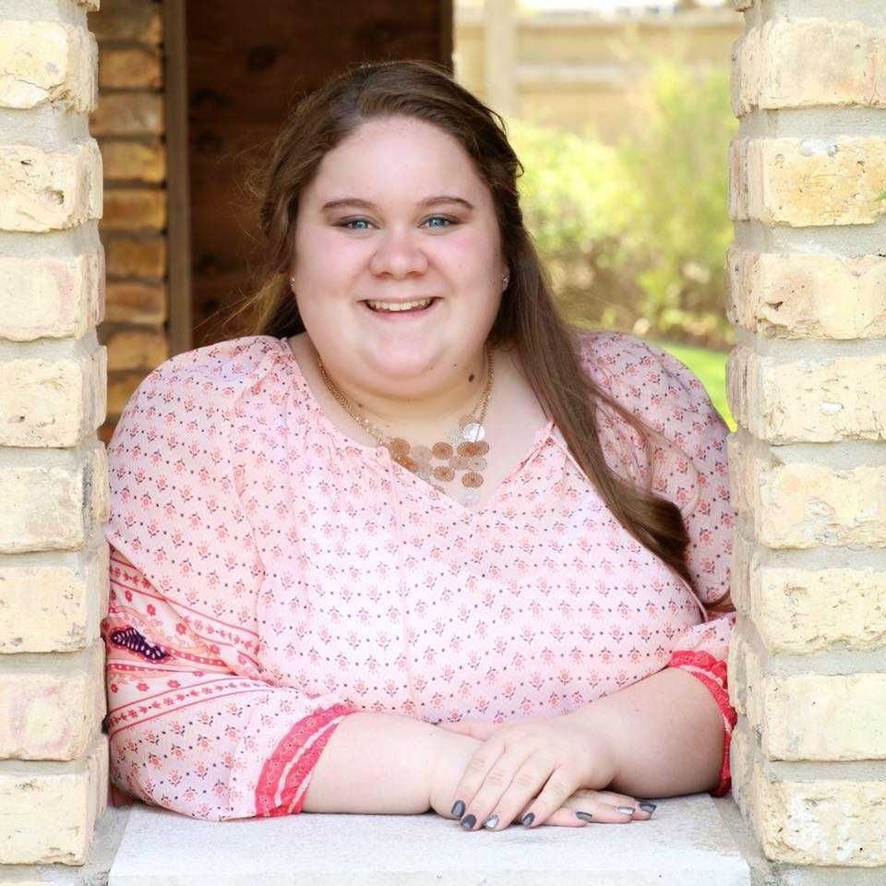

Ashby Grimes, Freshman

**Favorite color:** Dark Green

**Favorite place to eat:** Agave Azul (Mexican restaurant in Attica)

**Favorite animal:** OWLS!!

**Favorite Song:** Love wins- Carrie Underwood

**Favorite season:** Fall

**Previous FFA activities**: Parliamentary Procedure, Soils, Crops judging, District Leadership Contest

**Favorite memory of Purdue so far?** I loved going to collegiate exchange and hanging out with fellow classmates.

**Why Agriculture Education?** Ever since high school I have always enjoyed taking Ag classes and being involved in FFA, so I decided early that I wanted to shape the minds of the next generations all about agriculture and make a difference.

**Why Purdue?** Growing up in Lafayette my family and I would always cheer on the Boilers, so it was a big dream of mine to attend this great university!

**Favorite class at Purdue?** Horticulture 101 with Dr. Orvis!

**Greatest piece of advice?** Push yourself because, no one else is going to do it for you.

