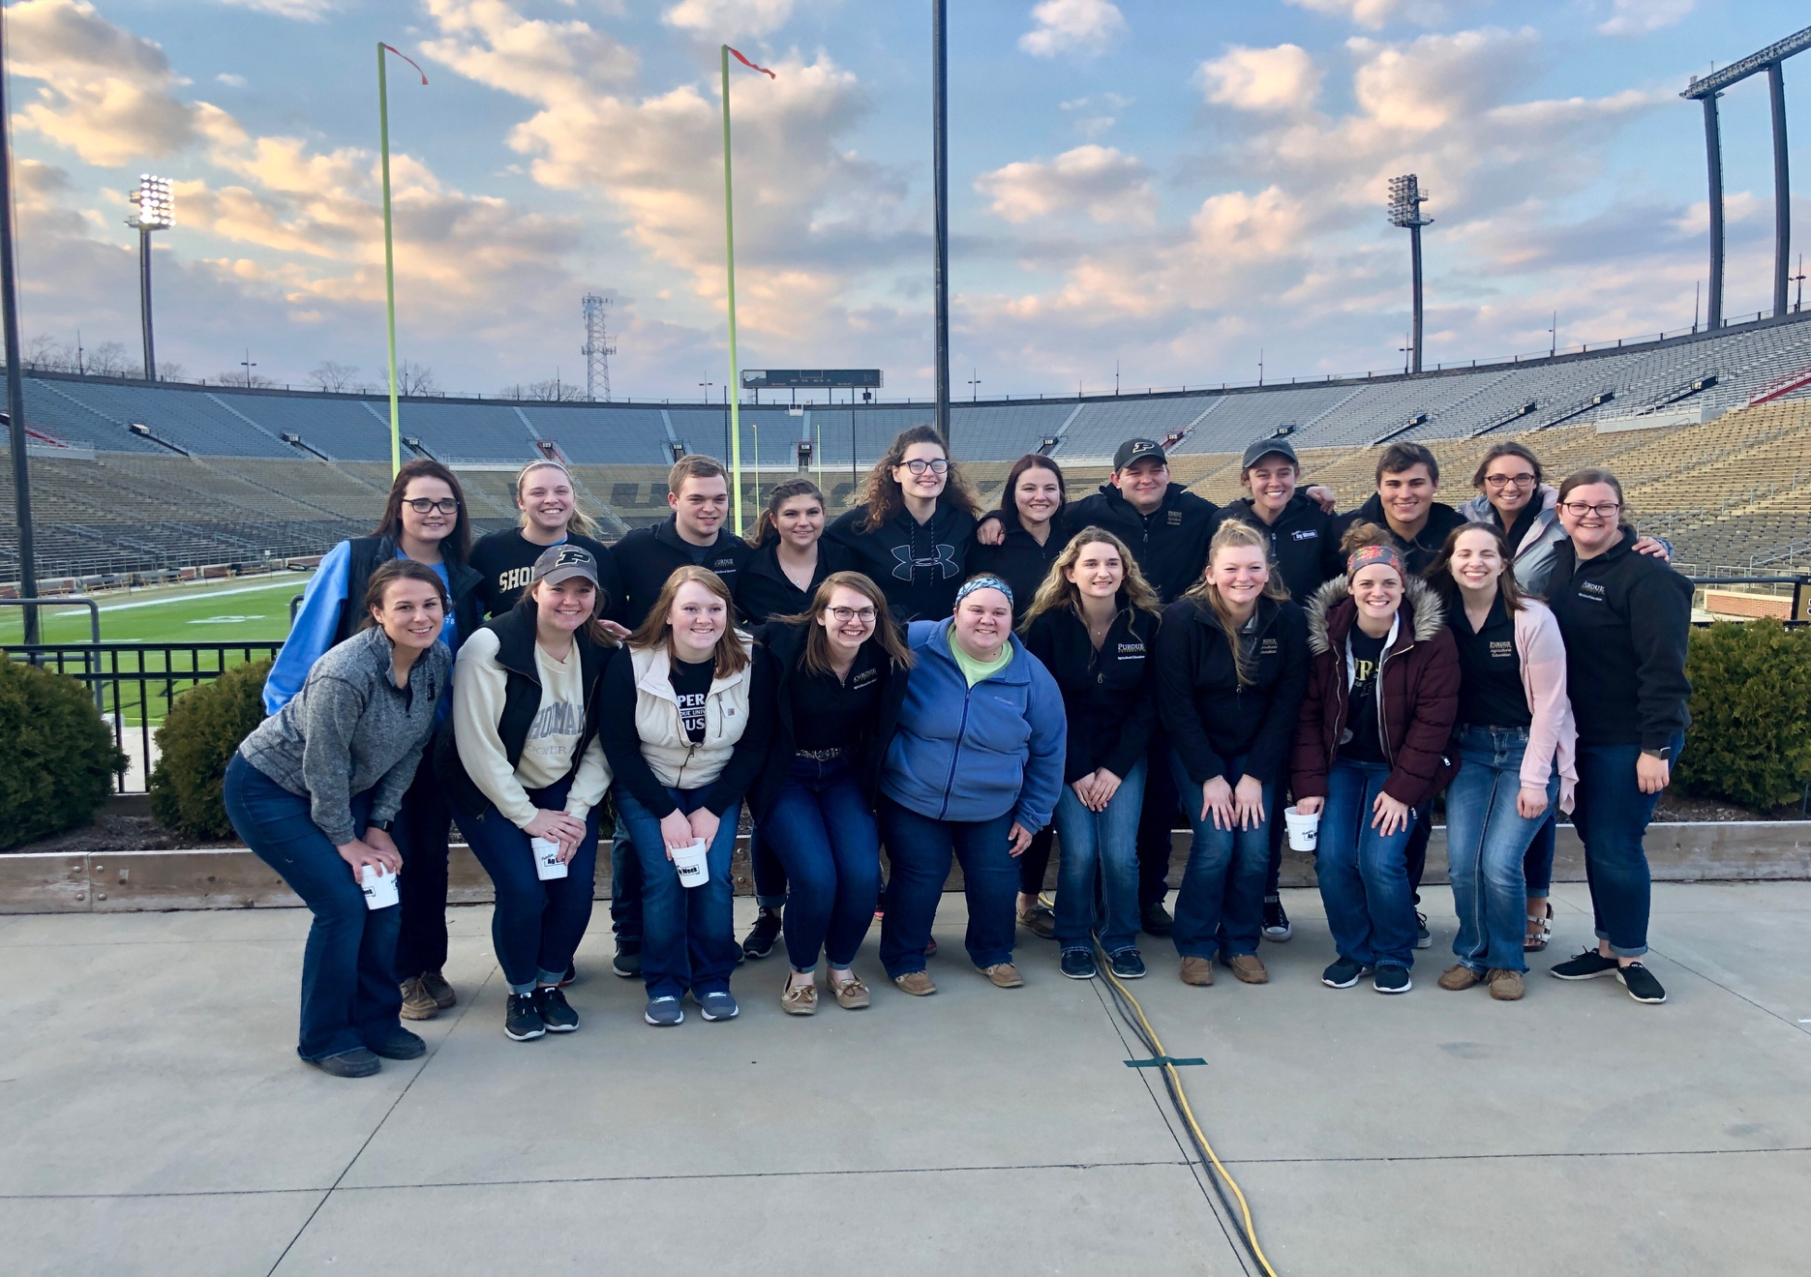

IAAE-Purdue Newsletter

2019 Hammer Down Hunger

* Spring Fling Recap
* Updated Agriculture Education Courses
* Senior Spotlight
* Ag Week Interview
* Jamaica Study Abroad Recap
* Summer Fun
* … and more!

What’s in this newsletter?

Welcome back everyone! We hope that everyone had a fun and relaxing summer. With summer coming to an end, it’s time to get excited for all the fun activities we have planned for you this year! We can’t wait for everyone to be back on campus. See you August 19th!

* IAAE-Purdue Officer Team
* August 24th: Non-Chicken Chicken BBQ
* August 28th: Ice Cream Social
* September 19th: IAAE Cook-off
* October 17th: Pumpkin Carving

Events to Look Forward to

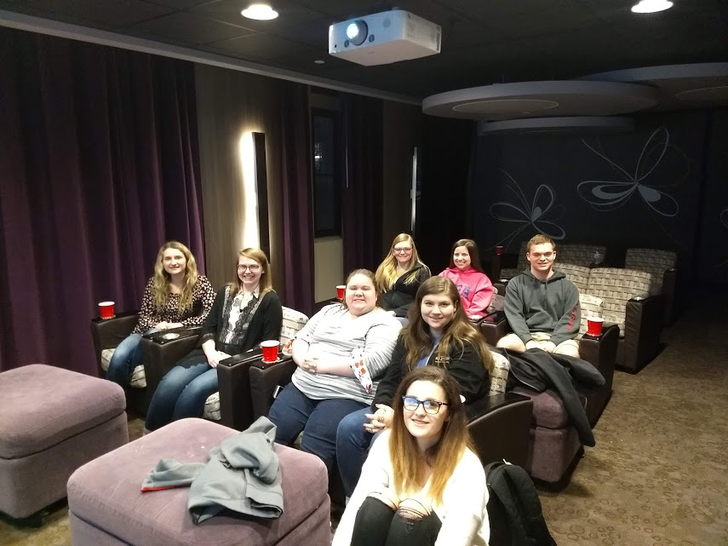

Updated Agricultural Education Courses

By: Brittany Young

On Tuesday, April 16, 2019, Amy Conrad, Dr. Sarah LaRose, and Dr. Allen Talbert shared about the curriculum changes within the agricultural education program. The changes shared include new courses as well as updated curriculum for classes that are already in place.

The future of agricultural education is looking very bright and leaving upper classmen sad that they were not able to experience these new courses, as well as excited for the future agricultural educators who will get to experience them! Professors met with past students and current agriculture educators who completed their undergraduate here at Purdue to hear from various perspectives on what improvements could be made to better prepare future teachers for the classroom.

           Changes to the course of study include more hands on classes that prepare students to know how to teach in lab settings, such as ag mechanics shops, animal science facilities, and greenhouses. Students will also be in actual classrooms more frequently to increase their overall observations and allow them to teach more often prior to methods or student teaching. Some courses will be going into effect in the fall 2019 semester but a good majority will be taking off in 2020 and into 2021.

There is not much of a better way to kick off spring than with a movie and pizza night with friends. Having fun with friends while relaxing by watching a movie can be the needed break in a busy college student’s schedule. On Sunday, March 24 the IAAE-Purdue held their annual Spring Fling at the theater in Windsor Hall. This years Spring Fling consisted of a good movie and pizza. The movie watched this year was Bohemian Rhapsody which is about the rock band Queen. Along with the movie and pizza members could enjoy popcorn and drinks. This event is a good way for members of IAAE-Purdue to have fun with friends while meeting other members.

Spring Fling

By: Kyle Swafford

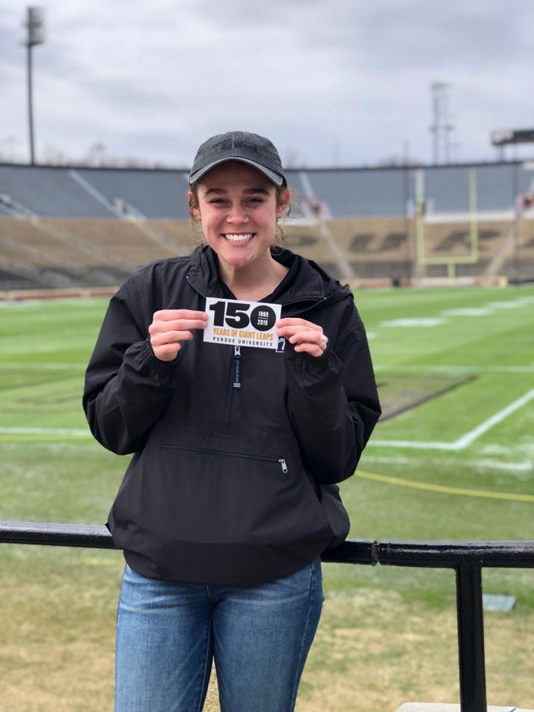

Ag Week Interview with Kylei Klein

By: Carly Grieshop

* What was your role during Ag Week?
  + This was my first year on the Ag Week Committee, so my role consisted of being a committee member, an idea giver, and an active supporter! On the team, we all work together as a unit to make Ag Week as successful as possible.
* Why did you choose to be apart of the Ag Week Committee and would you recommend it to others?
  + I chose to be apart of the Ag Week Committee because I wanted to be in a position to make a difference in the College of Agriculture. Ag Week is a time dedicated to advocating for agriculture all across the campus, and having a hand in that is incredibly rewarding. I would ABSOLUTELY recommend joining Task Force to anyone who is willing to work tirelessly and has a passion for agriculture.
* What was your favorite part/event of Ag Week?
  + My favorite part of Ag Week was our Hammer Down Hunger event! Not only did we have a great time packing meals with our fellow Boilermakers, but we also had the opportunity to feed 150,000 people all across the world! It is so amazing to me that we could bring our entire campus together to better the lives of others.



**Name-** Gabi Reese

**Student taught at -** North Montgomery High School

**Teaching at-** Beech Grove High School

**Teaching grades-**9-12

**What are you most excited for with your new position?** I am most excited to be apart of such a developed and growing program. I am excited to give ideas and help the chapter and program gain new members.

**What advice would you give to younger Purdue Ag Ed students?**Take every opportunity given to you.. even if it seems so out of your comfort zone. You never know the people you might meet or the life experiences that might come from it.



Senior Spotlight

By: Brittany Need

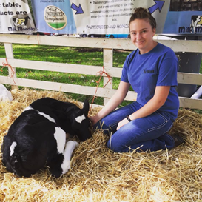

**Name-** Whitney Cross

**Student taught at-**North Newton

**Teaching at-** Lowell High School

**Teaching grades-** 9-12

**What are you most excited for with your new position?** I am most excited to work with my students in my classroom in order to create an inclusive environment where everyone is valued and has a place!

**What advice would you give to younger Purdue Ag Ed students?** Always check in with Amy & Talbert to make sure you're on track and doing everything you're supposed to do! College is tricky and confusing; it doesn't hurt to double check everything! I think it is also helpful to get into a classroom whenever you get the chance, even if it isn't Ag there is so much to learn from all of the teachers out there!

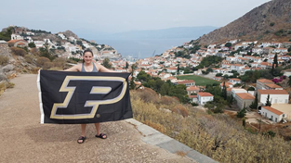

**Name-**Christy Mote

**Student taught at-** Jay County High School

**Teaching at-** Monroe Central

**Teaching grades-** 7-12

**What are you most excited for about your new position?** I am most excited about moving into a two-person agriculture education program and working alongside my

Senior Spotlight Cont…

colleagues. Starting out no one knows everything so I'm excited to learn from Mr. Weiler. I'm also excited about having my own classroom and teaching animal science.

**What advice would you give to younger Purdue Ag Ed students?** You may not know if you want to teach in the classroom, and that's okay. I encourage you to consider subbing at a local high school so that you can get experience in the classroom. One last thing is to do all the study abroad trips that you can. I went to Jamaica and Greece for 235 and I loved experiencing the different cultures.

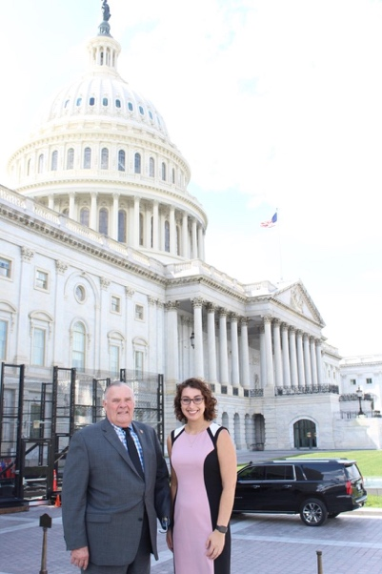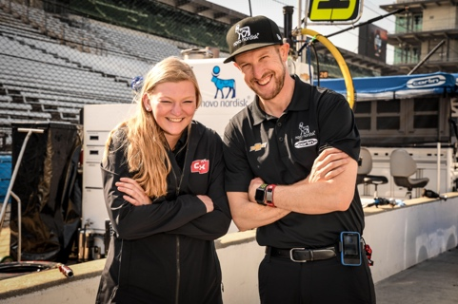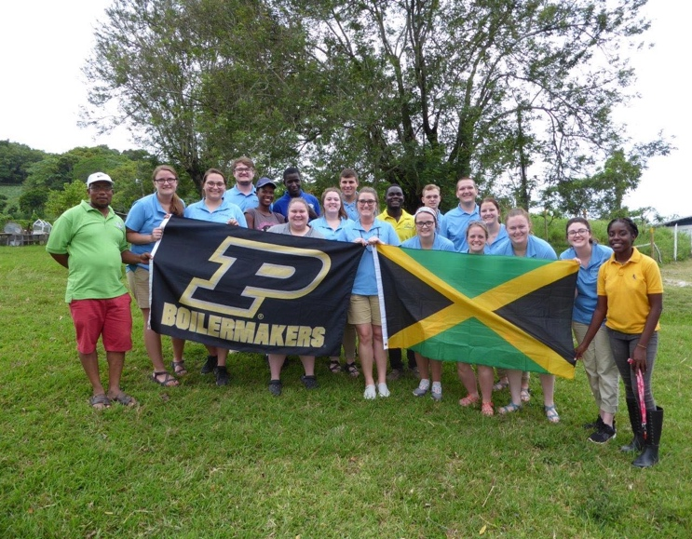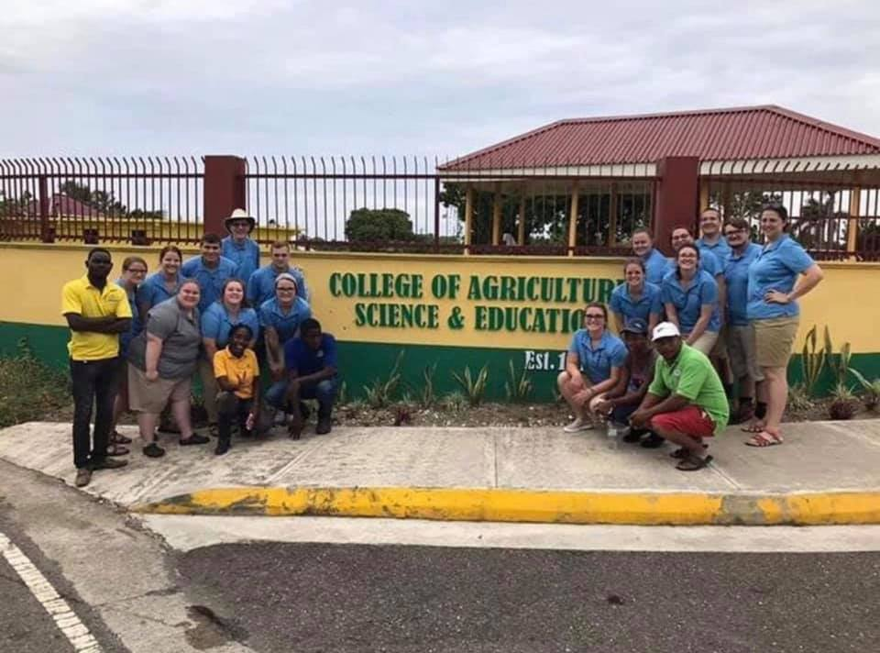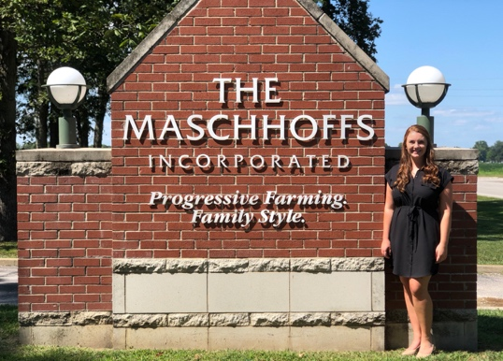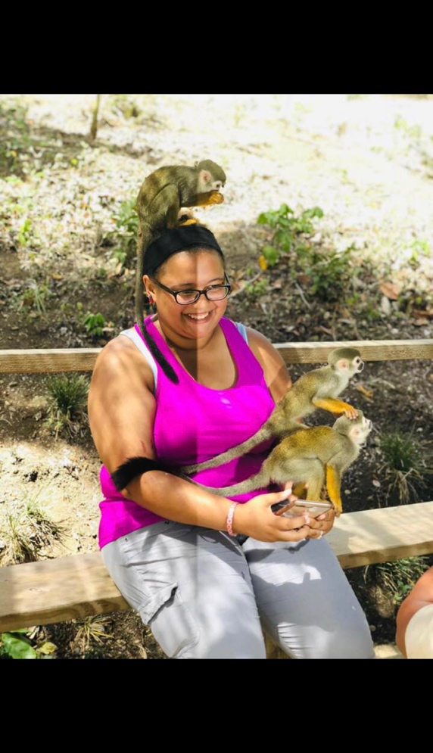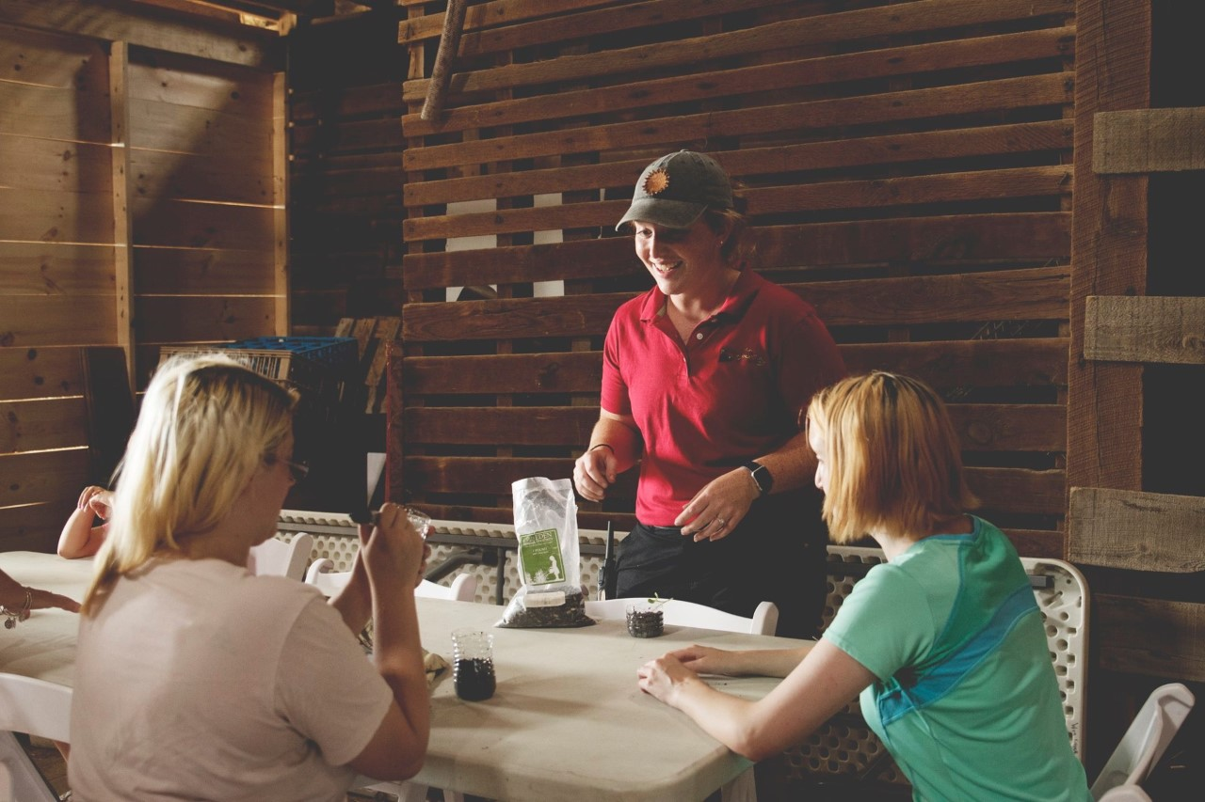

Congratulations to all of our 2019 graduates! We hope that you enjoyed your time at Purdue and are excited to be in the classroom!

IAAE Members’ Summer Internships

Morgan Winder

This summer I was working for Congressman Jim Baird in his Washington, D.C. office. This was a great opportunity to witness and participate in the legislative process up close. A typical week would include corresponding with constituents, giving tours of the Capitol Building, attending briefings and hearings, and assisting the legislative team with other miscellaneous tasks.

In May, I interned with Charlie Kimball who is an Indy car driver fro Carlin Racing. He is a type one diabetic and I helped him with marketing to his sponsors. I also helped manage aspects of his diabetes while he was in the car.

I also intern for Purdue Extension: Hancock County where I was a 4-H intern. I helped people with Fair Entry and helped find judges. I also helped during project judging and worked in the Jr. Leaders booth during the fair. As well as compiling results for the scrapbook that was in the newspaper for the results of all projects.

Lindsay Yeager

On May 14th, 13 of my fellow Agriculture Education classmates and I excitedly loaded a bus to Chicago. Two flights later, we were on another bus heading to our hotel in Kingston, Jamaica. The next 17 days were packed with tours, educational experiences, and memories to last a life time. We had the opportunity to tour CASE (College of Agriculture and Science Education) which is located in Port Antonio, Jamaica. Students from CASE gave us a tour of their farm which consisted of cattle, swine, poultry, and more. Wile walking around the farm and their greenhouses, we were able to compare their facilities to what we have in America. Along with touring the college, our classes were held at CASE. During class time, we dove into the meaning of multicultural education and why it is important for educators to fully understand it. When we were outside the classroom, our time was spent at the beach or touring many different places around Jamaica. These tours included Craighton Estate Coffee, JP Tropical Foods (bananas), Worthy Park Estate Sugar Processing Factory, Port Royal / Fort Charles, the Trident Castle, and the Bob Marley Museum. When we left Jamaica, we not only left with our bags full of souvenirs. We left with lifelong experiences that will carry over into our careers and will enable us to be the best teachers we can be.

Jamaica Study Abroad

By: Kayla Carson

I worked for the Maschhoff’s as a swine production intern working in breed to wean and wean to market sites learning about all the facets of pig production!

Kara Schueler

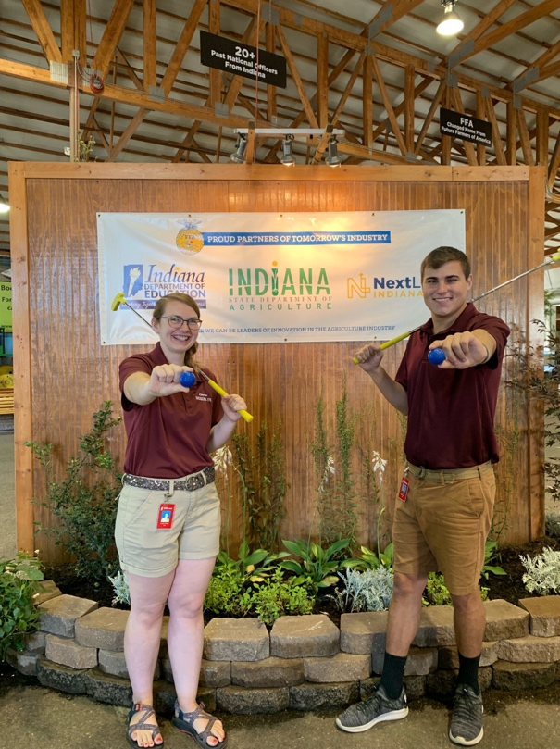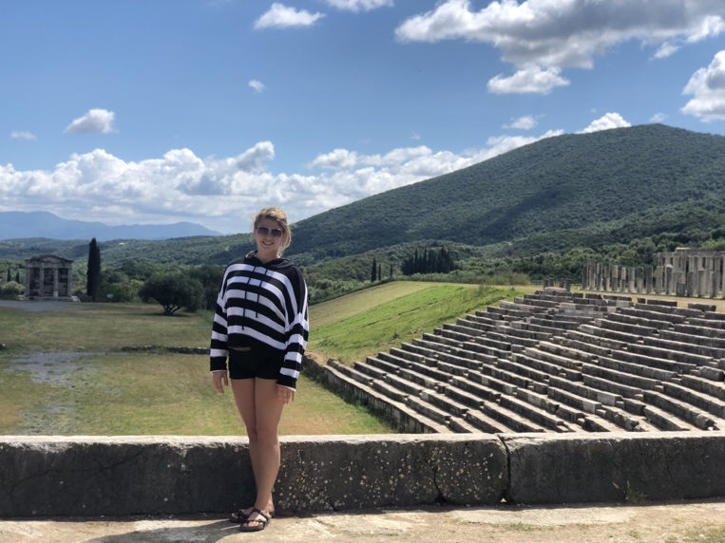

Grant Sanchez and Lauren Jacobs at their internship with the Indiana State Department of Agriculture. They had the opportunity to work in the FFA Pavilion at e State Fair where attendees can play a free round of putt putt and visit multiple areas of Agriculture featured, such as: urban agriculture, conservation, agriculture technology, and many more!

Summer Fun!

Morgan Alexander on the Greece study abroad trip for the College of Education

Kayla Patterson in the Dominican Republic

Mariah Merryman working at Wea Creek Orchard.